Smart Trash Bin Monitoring System
Farheen Sania
B.Tech Student, Department of Electronics and Communication Engineering, BVRIT Hyderabad College of Engineering for Women, India
Email:15wh1a0495@bvrithyderabad.edu.in
Abstract
As an aim to clean up the roads, streets and to develop the infrastructure digitally of India’s cities and rural areas. We have provided a solution to monitor the
Garbage level on the real time basis. The ultrasonic sensor in the garbage bin detect the
Garbage level continuously and accordingly the system provides the information to the
Municipality office. This will avoid the overflowing of the garbage bins. We use LDR sensor and Ultrasonic sensor to switch on light at night times near dust bin when the person is near the dustbin and detecting the gas evolved and fire accidents in the garbage.

Keywords: Arduino, GSM, Dustbin, Ultrasonic Sensor, Gas Sensor, Gas Sensor.

INTRODUCTION

One of the main problem with our environment is solid waste management which effects the health and environment of our society. The monitoring and management of trash is one of the primary problems of the present era.
Manually monitoring the trash in trash bins is a tough process and utilizes effort, time and money which can be prevented with our present technologies.
The Smart Trash Bin is a singular solution to the specific and peculiar problems in waste management. As the population is growing, million tons of garbage is produced every day by millions of people living in India, now the world’s third-largest trash generator.
However, the issue is that more than 40 million tons, of garbage is untreated by municipal authorities every day in an unhygienic manner leading to health issues and environmental degradation.
According to the Pune Municipal Corporation (PMC), Pune alone generates around 1600metric tons of solid waste daily in the form of organic, inorganic, bio-medical, and industrial Hazardous and e-waste etc. During the monsoon and festive season, the daily waste generation goes up by 15 to 20 percentages.
Moreover, the number of garbage pickers is less, which is insufficient to cover over all the households in the city. To encounter this problem, many people have come with their solutions like the Solid Waste Collection and Handling.
Moreover, the ‘Swachh Bharat Abhiyan’ of the central government has also been organizing various mass cleanliness drives and related events for the awareness of clean India.
This is a solution, in which trash management is automated. Garbage Monitoring system, an innovative way that will help to keep the cities clean and healthy [1,2].

WORKING
Naturally we come across road side scenes such as overflowed garbage bin, to overcome this problem we developed this project called Smart Trash Bin Monitoring System.
This project gives the percentage of trash in the bin using ultrasonic sensor [3, 4] and when the bin fills above 90% then an SMS will be sent to GHMC. We extended our project by adding gas sensor [5] to it. It sends an SMS when harmful gasses are released from the trash bin.
During night times as people can’t see the dustbin, they throw the trash beside the bin, to avoid this our project automatically switches on the light when it detects a person near the dustbin at the night [6-8].

How Arduino Work?
Arduino’s processor uses the Harvard architecture where it has separate memory for program and data. It has two memories- Program memory and the data memory. The code is stored in the flash program memory, whereas the data is stored in the data memory [9].
Arduino consists of 14 digital input/output pins, out of which 6 can be used as PWM outputs, a power jack, 6 analog inputs, a reset button, a USB connection, a 16 MHz crystal oscillator and an ICSP header.
Arduino is an open-source platform based on hardware and software. Arduino boards are able to read inputs - a finger on a button, a light on a sensor and turn it into an output - turning on an LED. You can tell your
board what to do by sending a set of instructions to the microcontroller on the board. We can tell the board what to do by the use of the Arduino programming language, and the Arduino Software, based
on Processing [10].

Figure1: Block Diagram

RESULTS
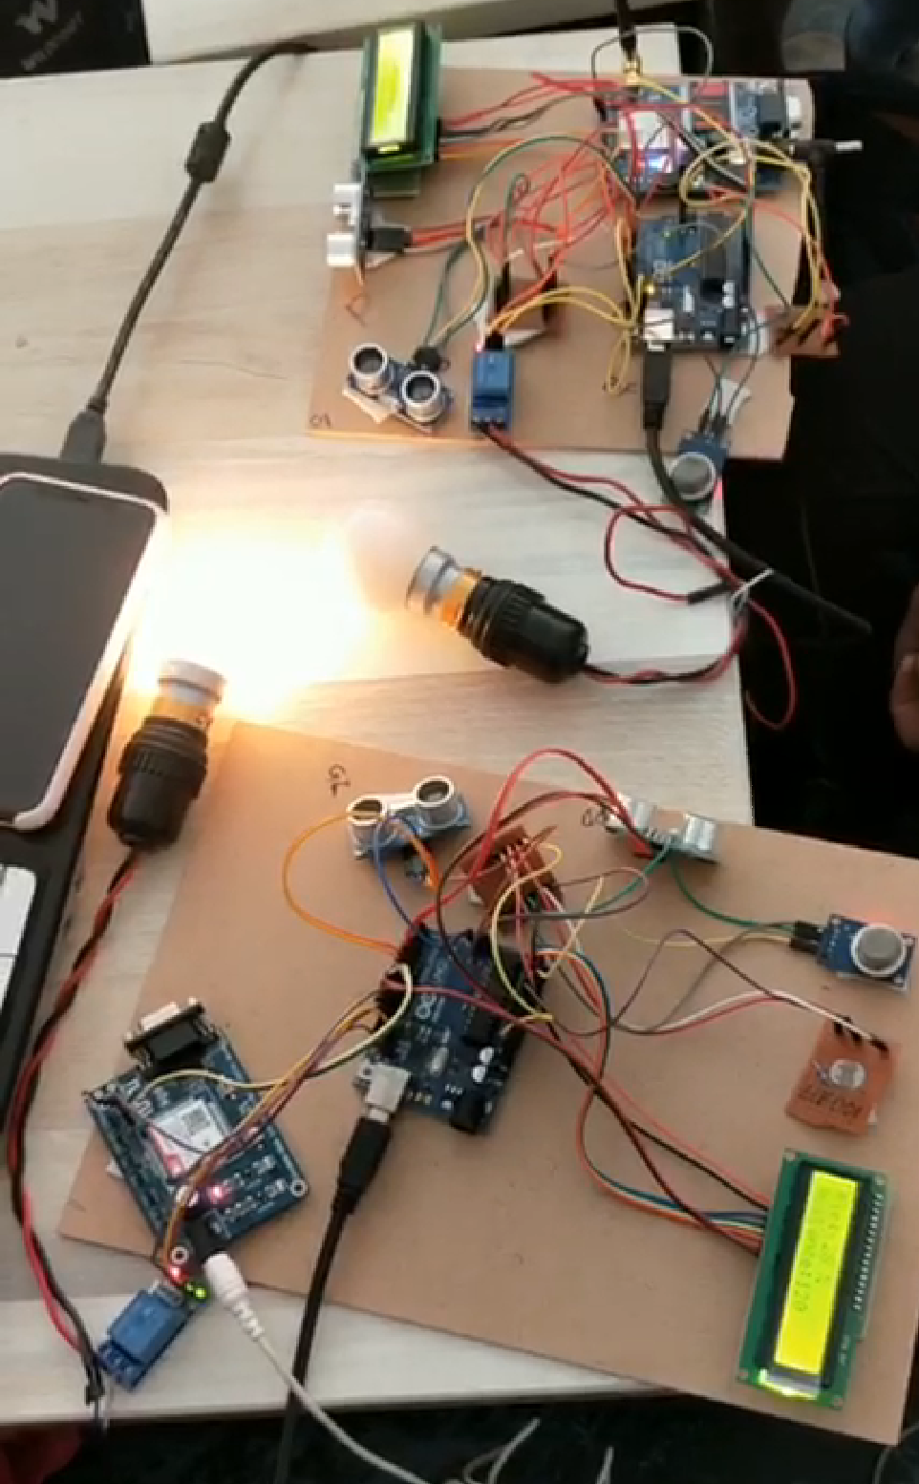
Figure 2: Connections
When Bin gets filled to a level of 90% or above the LCD displays “Bin is Full”
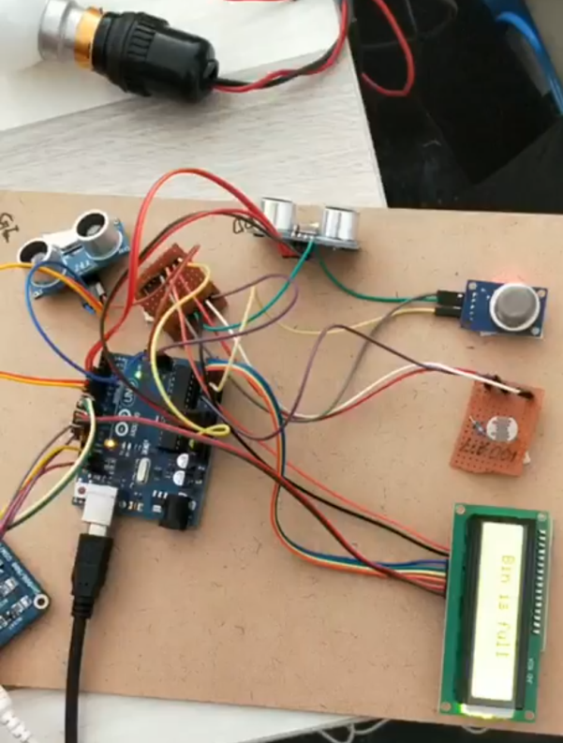
Figure 3: LCD Display when Bin is Full
When the Bin is filled it sends SMS to GHMC automatically using GSM. The SMS mentions the location of the BIN so that trash collectors can plan their route.
Figure 4: SMS Received
CONCLUSION
The work described in the paper is a huge step towards contributing to the Swachh Bharat program of the central government. It thus emphasizes on the feasibility of the prototype to be put into mass production pertaining to its simplicity in design and low production cost.
The Smart Trash Bin will improve the trash collection systems across the country. The features of garbage level sensing, automatic lid opening, garbage level sensing, and dynamic mobility will reduce the efforts required to collect trash as compared to other methods.
REFERENCES
[1]. https://www.instructables.com/id/Smart-Garbage-Monitoring-System-Using-Internet-of-/
[2]. https://swachcoop.com/
[3]. https://circuitdigest.com/microcontroller-projects/iot-garbage-monitoring-using-arduino-esp8266
[4].http://www.circuitstoday.com/interfacing-mq2-to-arduino
[5].https://electronics.howstuffworks.com/relay.htm
[6]. https://randomnerdtutorials.com/guide-for-relay-module-with-arduino/

[7]. https://www.maxbotix.com/articles/how-ultrasonic-sensors-work.htm

[8].https://howtomechatronics.com/tutorials/arduino/ultrasonic-sensor-hc-sr04/
[9].https://www.ijireeice.com/upload/2017/january-17/IJIREEICE%2015.pdf [10].https://www.matecconferences.org/articles/matecconf/pdf/2017/11/matecconf_etic2017_01098.pdf

